# Engineering Document Types

The following document types are identified at this point for use in Vioteq engineering work. The following acronyms will be used for these documents and they will follow the provided document intent. Use of this vocabulary and intent provides early stage alignment and minimization of wasted time in document creation.

All Vioteq documents will also be assumed of public visibility with no restriction unless explicitly stated. E.G. “Vioteq Confidential”, “Customer ABC Internal”, etc. This document for example has no restrictions visible and is thus assumed available for public distribution if needed.

The listing below follows softly the order of the build process, starting at conceptualization (PDRD) and ending in delivered product (Man).

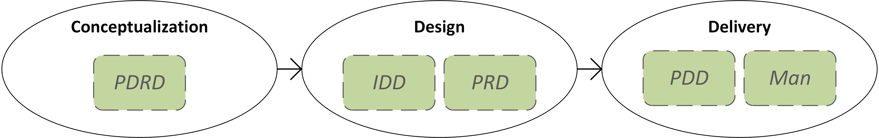

**Figure 1**: Design Cycle stages and document Segmentation in this process

## Prototype Definition & Requirements Document **(PDRD)**

This is the document which describes an idea, in the tangible and quantitative form of what you are going to build. This is initiated before a final or firm picture of the product has been generated, you simply know the flavor and the desired outcome at this point, and use the PDRD to help get you there.

This document covers the concept, the prototype identification and sometimes the market, need and customer. Miscellaneous topics may be included if identified as contributing value, E.G. testing or requirements.

## Internal Description Document **(IDD)**

A document used to define, explain or clarify any component of a product, technology or process which is intended for internal use. This definition is not as a requirement, but as an intent and a model. This may also be used along the path in transition from idea and PDRD onto and into a PDD or PRD.

## Product Requirements Document **(PRD)**

A document which defines what the product must do, in quantitative requirement. The PRD avoids description of how this is done, leaving that to the PDD and User Manual. The PRD may be written from the perspective of the end-user, to eliminate team bias and maximize alignment with the design and the requested target.

## Product Description Document **(PDD)**

A document which describes what was actually built, typically in short form with a target of a single page. Bulleted lists, graphics and block diagrams are emphasized, with a maximized emphasis on product communication with the intended audience of the user.

## User’s Manual **(Man)**

The culmination document for the product, intended specifically for the end user to provide assistance in use and troubleshooting or planning. This traditionally covers nearly all topics generated in the PRD and PDD and additionally includes a FAQ, Glossary and select Guides (e.g. installation or repair).